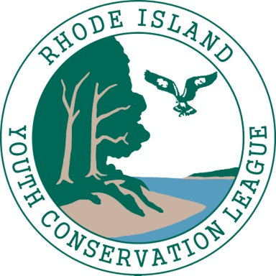
RI Youth Conservation League 2018
Crew Member Application

Name: Home Phone:
Email: Cell Phone:

DOB:

Permanent Address:

Summer Address (if different):

Name of Current School:

Grade Level Completed by June 30th:

Shirt Size: X-small Small Medium Large X-Large XX-Large

Are you available M-Th 8:00 am-4:30 pm, July 9th-August 9th 2018: Y / N

Do you have reliable daily transportation to the YCL Meeting Point?:
Location to be determined.

Short Answer: Please answer each with 3-6 sentences

1) The Youth Conservation League (YCL) relies on small groups to complete work projects. What life/work experiences have you had working cooperatively with others? What would you contribute to your crew?

2) Why do you want to work for the YCL? Please include at least three things you would like to learn from your YCL experience.

3) What do you anticipate being your biggest challenge while working on a YCL crew?

4) The best Crew Members have a positive attitude in spite of significant physical challenges (long days, heat, bugs, poison ivy, etc.) and are dedicated to completing a full term of employment. Do you feel that you are able to commit to the YCL for the specified crew time? Why?

5) Tell us about your greatest accomplishment. Why are you proud of it?

Please email the completed application to programadmin@rinhs.org with the subject header:
“YCL Crew Application: YOUR NAME”

Application Deadline: Friday, May 11th
25 minute interviews for potential candidates will be scheduled

Rhode Island Youth Conservation League is a collaborative program of the Audubon Society of Rhode Island and The Nature Conservancy. It is funded by a grant from the Rhode Island Conservation Stewardship Collaborative Endowment of the Rhode Island Foundation. YCL leaders and crew are employees of the Audubon Society of Rhode Island.

